<Image Gallery Software>

Use-Case-Realization Specification: <Forgot Password>

Version <1.0>

Revision History

|  |  |  |  |
| --- | --- | --- | --- |
| **Date** | **Version** | **Description** | **Author** |
| <dd/mmm/yy> | <1.0> | <details> | Nguyen Kiem Hoa |
|  |  |  |  |
|  |  |  |  |
|  |  |  |  |

Table of Contents

1. Introduction 4

1.1 Purpose 4

1.2 Scope 4

1.3 Definitions, Acronyms, and Abbreviations 4

1.4 References 4

1.5 Overview 4

2. Use-Case Specification 4

3. Interaction Diagrams 5

4. Class Diagrams 6

5. Derived Requirements 7

Use-Case-Realization Specification: <Forgot Password>

# Introduction

## Purpose

This document describes how the Forgot Password Use-Case is realized within the design model, in terms of collaborating objects.

## Scope

This document applies to the Image Gallery Software which will be developed Group 5C-18.

## Definitions, Acronyms, and Abbreviations

User – a person who use the software.

## References

None.

## Overview

In the following section, Use-Case Realization Specification of the Forgot Password Use-Case of the Image Gallery Software is provided in detail. The first section is a textual description of the Use-Case specification. The following section contains diagrams (sequence and collaboration diagrams) describing how the use case is realized in terms of collaborating objects. The third section includes class diagrams with relationships that participate in the realization of the use case. The last section is an analysis of all requirements, such as non-functional requirements, on the use-case realization that are not considered in the design model, but that need to be taken care of during implementation.

# Use-Case Specification

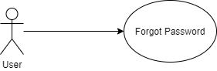

|  |  |
| --- | --- |
| **Name** | Forgot Password |
| **Brief Description** | A user retake their password |
| **Actor** | User |
| **Flow of Events** | |
| **Basic Flow** | |
| 1. User open login page. 2. User click on Forgot Password. 3. The system prompts user for username. 4. The user enter their username. 5. The system verify username. 6. The system send password to user. | |
| **Alterante Flows** | |
| **Title** | **Description** |
| Authentication fail | 1. User enter invalid username. 2. System displays message to correct invalid username. |
| **Pre-Conditions** | |
| Not empty field. | |
| **Post-Conditions** | |
| **Title** | **Description** |
| Success | Success message is prompted and user enter login screen. |
| Failure | The user is unable to get password because invalid username. |
| **Extension Points** | |
| None | |

# Interaction Diagrams

**Sequence Diagram:**

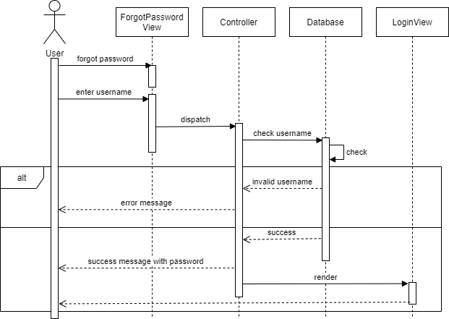

**Collaboration Diagram:**

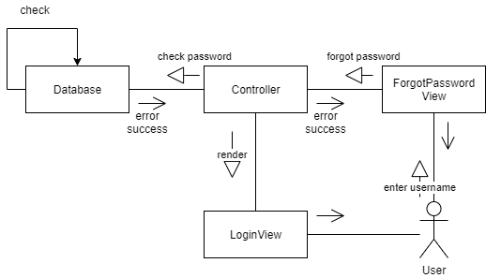

# Class Diagrams

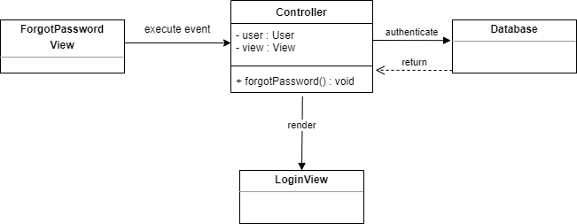

# Derived Requirements

None.